***Experiment 3***

**Aim:** Implement the classic Map Reduce word count algorithm to count the frequency of words in a large text corpus stored in HDFS.

***Directory:***

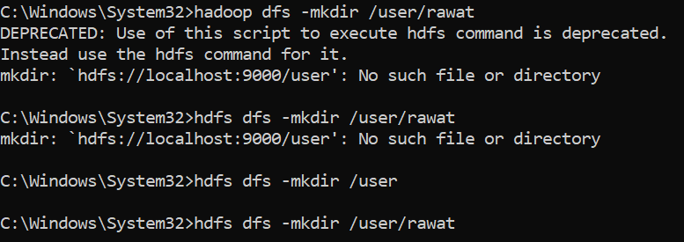

***Fig 1: Making Directory***

***Map Reduce Job:***

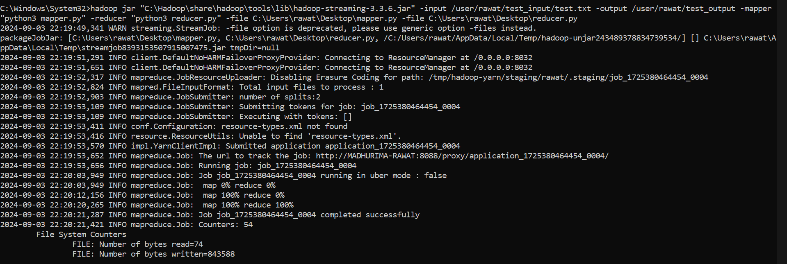

***Fig 2: Executing Map Reduce Job***

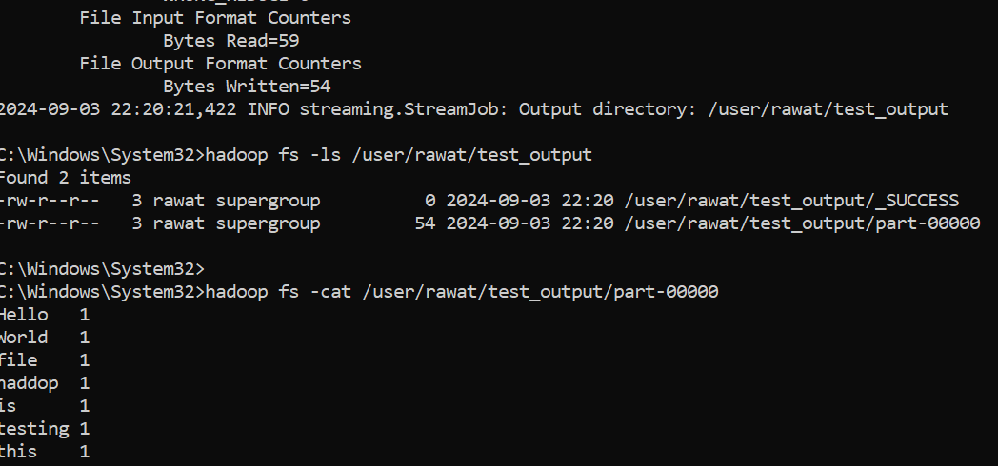

***Fig 3: Output of Map Reduce Job***